RHPWG Emissions Inventory and Modeling Protocol Subcommittee Call
  - Agenda and Notes by Frank Forsgren
  - September 26, 2018
  - 800-768-2983 access code 4918837035

wiki page link: http://views.cira.colostate.edu/wiki/wiki/9191

Agenda Items:
- Welcome, Roll Call, Agenda Review – Farren
States
AZ-Ryan T, CA-Tina, Stephanie and Jim, CO-Kevin, Curt, Dale, and Jeremy, MT-Stephen C, NV-Brenda and Frank, NM-Mark Jones, ND-Rob White and Angela, UT-Jay, WA-Farren.

Locals
RAQC, CO-Amanda, Pima County, AZ-Janice

FLM
USFWS-Tim A, NPS-Mike B

WRAP
WRAP-WESTAR-Tom M. and CIRA-Rodger Ames

- Notes from July and August calls – no comments. Who is our note taker for this call!? Volunteer please! – Farren
No comments on notes from last calls, but minor internal edits made prior to posting. Frank, NV, volunteered for call notes. Farren will develop a notetaking schedule for next call and thereafter.

- Completing the 2014 NEIv2 data review - Farren
- States still need to provide updates for minor-source inclusion table (starting table in last meeting notes).
Discussed table listing states that submit minor source data to the NEI and identified need to reach out to all states to finish populating this table, especially AK, HI, ID, MT, OR, SD, UT, and WY.

 | Minors Submitted to EPA?
Alaska | Yes (see updates on wiki)
Arizona | Pima County says No – AZDEQ: No
California | Yes - All minors submitted for NEI years
Colorado | Yes - All sources down to 1 ton
Hawaii | No
Idaho | No
Montana | Yes – Sources down to 25 tons except portables
Nevada | Yes - All minors submitted for NEI years
New Mexico | No
North Dakota | No
Oregon
South Dakota | No
Utah
Washington | No
Wyoming | Yes - All minors submitted for NEI years

- States need to check with local agencies for any remaining emissions updates needed
Identified need for states with local air agencies (AZ, CA, NV, NM, OR, WA) to reach out to locals for NEI updates as needed.

- MOVES input file submittal for 2014 – each state to check and send as needed (and county air districts as applicable)
• The 2014 NEI v2 documentation discusses this in section 6.2.1 here.
- The representative/reference county CDBs are posted here.
- Input data displayed at this link is in a different format than what was submitted to EPA NEI, but is model-ready.
• Map shows in dark blue which counties submitted to 2014 NEI v2
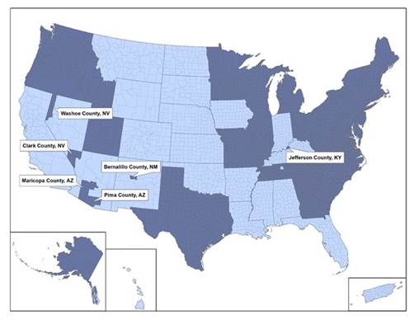
Map image above shows ID, OR, and WA and Maricopa and Pima Counties in AZ, Clark and Washoe Counties in NV, and Bernalillo County in NM submitted activity data for MOVES to populate the 2014 NEI. CA submits mobile source emissions directly (output from EMF).

- Last call for base-case RH Modeling emissions updates (relative to 2014 NEI). Final Due Date is Oct. 5.
Requested any changes to 2014 inventory by October 5, including stack parameter changes.

- Re-organization format for wiki page – Rodger
Rodger is reorganizing portions of the emissions wiki to make key outcomes and pending issues and tasks more accessible near the top of the page. The SC is preparing a summary of the wiki for posting. Rodger added new Option 3 emissions review tool to wiki. Rodger will work behind the scenes with Farren and Tom on the updates. Send comments or suggestions to Farren, Tom, or Rodger.

- Upcoming: checklist for what states need to review (base and future) – Farren
Developing checklist for base case inventory and projected inventory to facilitate inventory reviews, which will be reviewed on the next call. There will be a final v2 base year inventory to capture any last minute changes needed. The SC will document assumptions for on-the-way and on-the-books projected inventories.

- Upcoming: document that summarizes the subcommittee recommendations and emissions updates – Farren
Stressed importance of documentation of EI development, methodologies, and review process and need to capture findings of each review cycle for dissemination to broader audience. Suggested this will be a living document on the wiki, refreshed for every review cycle.

- Next Call 11 am Pacific; Oct. 25 (Thursday) - all

